**Journal of Cardiovascular Aging**

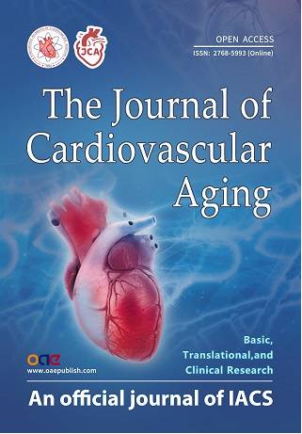



***Editor:***

**Dr. Ali J. Marian**

***Editorial Office:***

*The Journal of Cardiovascular Aging*

OAE Publishing Inc.

245 E Main Street Ste 107,

Alhambra, CA 91801, USA

Email: [editorialoffice  
@cardiovascularaging.com](mailto:editorialoffice@cardiovascularaging.com);

[cardiovascularaging@gmail.com](mailto:cardiovascularaging@gmail.com)