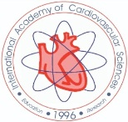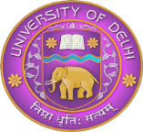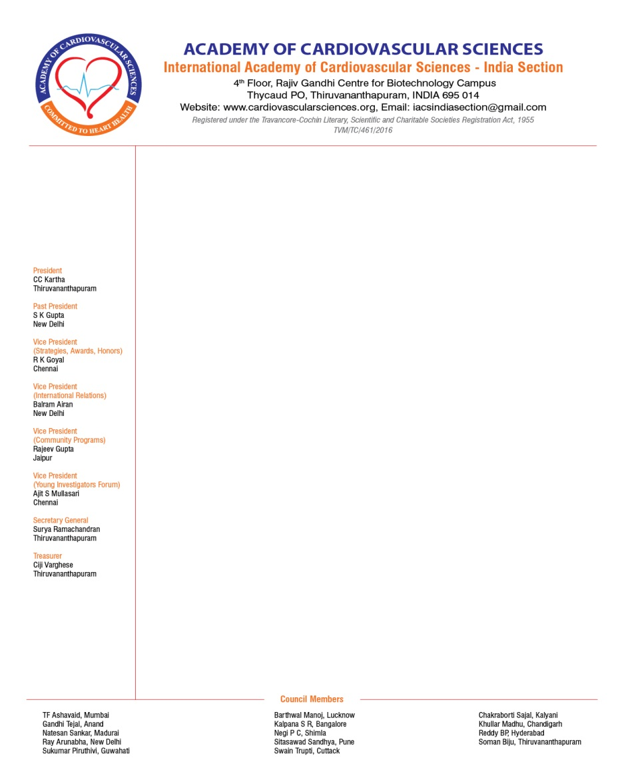

International Conference on

Recent Advances in Cardiovascular Research: Impact on Health and Disease

**9th Annual Conference of International Academy of Cardiovascular Sciences**

**(India Section)**

**09 – 11 February, 2017**

***Venue***

**Vallabhbhai Patel Chest Institute**

***Paintal Memorial Golden Jubilee Auditorium***

**University of Delhi North Campus, Delhi-110 007 (India)**

***Patrons***

**Prof. N.S. Dhalla (Executive Director) Prof. C.C. Kartha (President)**

**Prof. S.K. Gupta (Past President) Prof. S.N. Gaur (Director, VPCI)**

***Organizing Chairman Organizing Secretary***

**Prof. A. Ray Prof. Kavita Gulati**

Head, Dept. of Pharmacology, VPCI Dept. of Pharmacology, VPCI

***Invitation***

Dear Colleague,

Greetings from Vallabhbhai Patel Chest Institute, University of Delhi, Delhi, India

We have great pleasure in informing you that the Vallabhbhai Patel Chest Institute, University of Delhi, is organizing an **International Conference on Recent Advances in Cardiovascular Research: Impact on Health and Disease (9th Annual IACS –India Meeting), from 09 – 11 February, 2017** at the Paintal Memorial Golden Jubilee Auditorium of the institute. This conference is being organized in collaboration with the Academy of Cardiovascular Sciences (International Academy of Cardiovascular Sciences-India Chapter).

Cardiovascular disorders are a major cause of morbidity and mortality worldwide and newer strategies aimed at prevention, diagnosis and treatment are constantly being devised. The main theme of the present conference will be - A translational approach for cardiovascular research and therapy that is transfer of information generated by research in the laboratory to the patient in the clinical setting. Eminent cardiovascular scientists, cardiologists and cardiothoracic surgeons of national and international repute will participate in this conference and interact on a common platform to evolve sustainable solutions to mitigate dire consequences of cardiovascular pathophysiology. The conference will include sessions on basic and clinical sciences and will deliberate on the recent developments in disorders like hypertension, heart failure, ischemic heart disease, myocardial infarction, arrhythmias, metabolic syndrome, cardiovascular complications of diabetes, atherosclerosis, vascular abnormalities etc. Interactions between traditional and modern medicines and role of nutraceuticals in the area of cardiovascular disorders will be important target areas of the scientific deliberations. Experts, delegates and resource persons from across the world viz. Canada, USA, Europe, Australia, in addition to eminent experts from India will participate in this epic meeting.

On behalf of the organizing committee, it is our distinct honor and proud privilege to cordially invite you and your colleagues to this conference at Delhi, India, and to actively participate in and contribute to this conference.

You have been a constant source of support and encouragement to scientific activities of our institute and the IACS, and we eagerly look forward to your cooperation and support, in making this event a grand success.

Looking forward to welcoming you at Vallabhbhai Patel Chest Institute, Delhi, in February, 2017

**Prof. S.N. Gaur Prof. Arunabha Ray Prof. Kavita Gulati**

Patron Organizing Chairman Organizing Secretary

Director, VPCI VPCI VPCI

***Members***

Mr. Tarun Malhotra

Prof. Balakrishna Menon

Dr. Mujib-Ur-Rehman

Prof. Vishwajit Rohil

Mr. D.K. Sahoo

Mr. P.R. Santhanam

Prof. Malini Shariff

Mr. R.K. Sharma

Mr. Satish Sharma

Mrs. Uma Tyagi

Prof. Mandira Varma

Dr. Rajinder Bajaj

Prof. S.K. Bansal

Prof. Vishal Bansal

Prof. Anuradha Chaudhary

Dr. Nitin Goel

Prof. Anita Kotwani

Prof. Ritu Kulshrestha

Mr. Arun Kumar

Mr. Pradeep Kumar

Prof. Raj Kumar

***Advisory Committee***

Prof. S.R. Kalpana (Bangalore)

Prof. C.C. Kartha (Thiruvananthapuram)

Dr. C.K. Katiyar (Kolkata)

Prof. Madhu Khullar (Chandigarh)

Prof. Raj Kumar (Delhi)

Prof. S.K. Maulik (New Delhi)

Prof. Anita Mehta (Ahmedabad)

Dr. Ajit S Mullasari (Chennai)

Prof. Sankar Natesan (Madurai)

Prof. P.C. Negi (Shimla)

Prof. G.N. Qazi (New Delhi)

Prof. Rais Ur Rahman (New Delhi)

Dr. Surya Ramachandran (Thiruvananthapuram)

Prof. K. Ravi (Delhi)

Dr. Bhanu Prakash Reddy (Hyderabad)

Prof. Pawan Singal (Canada)

Dr. Shashi Bala Singh (Delhi)

Dr. Sandhya Sitasawad (Pune)

Dr. Biju Soman (Thiruvananthapuram)

Dr. Trupti Rekha Swain (Cuttack)

Dr. Ishwar N Acharya (New Delhi)

Dr. Amit Agarwal (Bangalore)

Prof. Devendra Agrawal (USA)

Prof. S.S. Agrawal (New Delhi)

Prof. Balram Airan (New Delhi)

Dr. T.F. Ashavaid (Mumbai)

Dr. Mohd. Aslam (New Delhi)

Dr. Somnath Bandopadhyay (Kolkata)

Prof. S.K. Bansal (Delhi)

Dr.Manoj Barthwal (Lucknow)

Dr. Jaideep Bhaduri (Pune)

Dr. Seema Bhargava (New Delhi)

Prof. Sajal Chakraborty (Kalyani)

Prof. N.S. Dhalla (Canada)

Prof. Madhu Dikshit (Lucknow)

Prof. Tejal Gandhi (Anand)

Prof. R.K. Goyal (New Delhi)

Dr, Rajeev Gupta (Jaipur)

Prof. M. Gupta (USA)

Prof. S.K. Gupta (New Delhi)

Prof. Suresh Tyagi (USA)

***About IACS***

**The International Academy of Cardiovascular Sciences (IACS) was started in1996 by the eminent, scientist, scholar and global visionary, Professor Naranjan S Dhalla (Winnipeg, Canada), who is the Founder and Executive Director. The IACS is structured with an international executive and board members, with headquarters in Winnipeg, Manitoba, Canada. At present, the Academy has established seven sections in India, Japan, China, Russia, Europe, South and North America which are operating independently, but in a coordinated fashion. The India Section of the IACS was initiated in 2004 on the proposal of Prof. Naranjan S Dhalla, with Professor N.K. Ganguly, former DG, ICMR and eminent microbiologist and Professor of Experimental Medicine &Biotechnology (PGIMER, Chandigarh) as its first President. The aim of the society is to promote cardiovascular education and to recognize major cardiovascular achievement throughout the world. The India Section of IACS has established its viability over the years and is now a vibrant scientific society aimed at promoting novel activities for the growth of the practice of cardiovascular research in India. The IACS (India Section) has now created its identity and niche for itself and provided an attractive platform for basic scientists, cardiologists, surgeons and epidemiologists as well as the public. The Executive Council of the IACS (India Section) is now registered as *Academy of Cardiovascular Sciences*, an independent body under The Travancore-Cochin Literary, Scientific and Charitable Societies Registration Act, 1955. A new website has also been launched *(www.cardiovascularsciences.org).* The council members represent National Institutes, Medical Colleges and Universities of different regions/States of India and various disciplines related to cardiovascular sciences. There is also adequate representation of women (30%) as well as young scientists in the Council. The IACS (India Section) is thus a society of distinguished medical scholars and the primary objective of an Academy is devoted to the growth and development of cardiovascular sciences for the welfare of mankind. In the process, it will bring together and into its fold, all types of professionals in the field, viz. cardiologists, cardiovascular surgeons, pathologists, pharmacologists, physiologists, public health experts and nutritionists. The IACS (India Section) is now expanding its membership by enlisting investigators/professionals form different disciplines related to cardiovascular and allied sciences and from different parts of India.**

***IACS (India Section) Executive Committee***

**President:** Prof. C.C. Kartha (Thiruvananthapuram)

**Immediate Past President:** Prof. S.K. Gupta (New Delhi)

**Vice Presidents:** Prof. R.K. Goyal (New Delhi)

Prof. Rajeev Gupta (Jaipur)

Prof. Airan Balram (New Delhi)

Prof. Ajit S Mullassari (Chennai)

**Secretary General:** Dr. Surya Ramachandran (Trivandrum)

**Treasurer:** Dr. Ciji Varghese (Trivandrum)

*Council Members*

Prof. PC Negi (Shimla)

Dr. Sukumar Pirithivi (Guwahati)

Prof. Arunabha Ray (Delhi)

Dr. BP Reddy (Hyderabad)

Dr. Sandhya Sitaswad (Pune)

Dr. Biju Soman (Trivandrum)

Dr. Trupti Rekha Swain (Cuttack)

Dr. TF Ashavaid (Mumbai)

Dr. Manoj Barthwal (Lucknow)

Prof. Sajal Chakraborti (Kalyani)

Prof. Tejal Gandhi (Anand)

Dr. SR Kalpana (Bangalore)

Prof. Madhu Khullar (Chandigarh)

Dr. Sankar Natesan (Madurai)

*Executive Director:* **Prof. N.S. Dhalla (Winnipeg, Canada)**

***About Vallabhbhai Patel Chest Insitute***

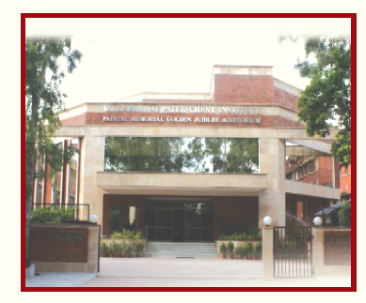The Vallabhbhai Patel Chest Institute (estab. 1949) is a unique postgraduate medical institute devoted to teaching, research and patient care in the area of chest diseases and allied biomedical sciences. The Institute is located in the heart of the main campus of University of Delhi providing the requisite academic environment in which a wide range of scientific activities are carried out by the various departments of the institute. This institute has delivered scientific contributions in the area of basic and clinical sciences. The discovery of lung deflation receptors (J Receptors) by the late Prof. A. S. Paintal (Physiology) and the characterization of a novel regulatory lung peptide (Pneumadin) by late Prof. Ashwini Kumar (Pharmacology), are important landmarks in the history of the institute, both of which have been recognized at the highest level. During the last decade, the development and modernization of the clinical and basic research facilities under the dynamic leadership of its illustrious Directors has been an outstanding achievement. The Department of Pharmacology, which was established in 1967, is currently involved in preclinical and clinical research in the area of cardio-respiratory pharmacology and toxicology, stress pharmacology and nitric oxide research with specific emphasis on a translational approach.

* Cardiac arrhythmias
* Cardiac biomarkers
* Cardiac failure
* Cardiac remodeling
* Cardiomyopathy
* Cardiotoxicity and drugs
* Clinical trials in cardiovascular diseases
* Diabetes and cardiac disease
* High altitude and cardiovascular physiology
* Hypertension
* Immunocardiology
* Newer experimental models
* Ischemia reperfusion injury
* Ischemic heart disease
* Nanotechnology in cardiovascular therapy
* Neurocardiology
* Nutraceuticals and medicinal plants in cardiac disease
* Obesity and cardiac disease
* Peripheral vascular disease
* Pulmonary hypertension
* Traditional systems of medicine (AYUSH) in cardiovascular therapy
* Vascular biology and angiogenesis
* Advances in nitric oxide research

***Conference highlights/topics***

***Invited Speakers***

Prof. Rajeev Gupta (Jaipur)

Prof. SK Gupta (New Delhi, India)

Dr. SR Kalpana (Bangalore, India)

Prof. CC Kartha (Trivandrum, India)

Prof. Madhu Khullar (Chandigarh, India)

Prof. SK Maulik (New Delhi, India)

Prof. Ajit S Mullasari (Chennai, India)

Dr. Surya Ramachandran (Trivandrum, India)

Prof. Pawan Singal (Winnipeg, Canada)

Dr. Sandhya Sitaswad (Pune)

Dr. Biju Soman (Trivandrum, India)

Prof. Suresh Tyagi (Louisville, USA)

Dr. Andras Varro (Hungary)

Prof. Hong Wang (Philadelphia, USA)

Prof. Xiaofeng Yang (Philadelphia, USA)

Prof. Devendra Agrawal (Omaha, USA)

Prof. SS Agrawal (New Delhi, India)

Dr. TF Ashavaid (Mumbai)

Prof. Airan Balram (New Delhi, India)

Dr. Manoj Barthwal (Lucknow)

Prof. Balram Bhargava (New Delhi, India)

Prof. Harpal Buttar (Ottawa, Canada)

Prof. Sajal Chakraborti (Kalyani)

Dr. Suvro Chatterjee (Chennai, India)

Prof. Y. Eugene Cheng (Ann Arbor, USA)

Prof. NS Dhalla (Winnipeg, Canada)

Dr. Madhu Dikshit (Lucknow, India)

Prof. Tejal Gandhi (Anand)

Prof. RK Goyal (New Delhi, India)

Prof. Mahesh Gupta (Chicago, USA)

***Orations***

1. Prof. S. K. Gupta Oration
2. Prof. R. K. Goyal Oration
3. Prof. H. S. Buttar Oration
4. Prof. R. K. Kukreja Oration

***Award Competitions at IACS-2017 Conference, Delhi***

1. **Suresh C Tyagi Symposium** (for young faculty)

Four speakers will be selected on the basis of applications submitted for this purpose

1. **Devendra Agrawal Young Investigator Award Competition**

Four Ph.D. students/ postdoctoral fellows (below 35 years) will be selected on the basis of abstracts submitted for this purpose

1. **Naranjan Dhalla Poster Award Competition**

Four Poster Awards – selected on the basis of posters presented during the conference

1. **C.C. Kartha Travel Grants** (for Young Investigators below 35 years)

Ten travel awards. To be selected from applications submitted for this purpose

Applications are invited for **the above awards** along with age proof, brief bio-data and abstracts and conference registration to be sent to: **Prof. Kavita Gulati, Organizing Secretary, IACS-2017 Conference, Department of Pharmacology, Vallabhhai Patel Chest Institute, University of Delhi, Delhi-110 007,** latest by **30 November, 2016.** The applications will be short listed by a committee duly constituted by the IACS-2017 Executive and awardees will be duly intimated. **It is mandatory that these applicants should also register for the conference by the application deadline.**

***Abstract submission***

Abstracts for all papers for award and poster sessions should be limited to 500 words, typed on A4 size paper in Word file, Times New Roman, 12 font size. Title should be in bold, and presenting author should be underlined.

**Last date for all abstract submissions is 30 November, 2016.**

***Registration form***

**Name (Block Letters): _______________________________________________________**

**Designation: _______________________________________________________________**

**Qualifications: _______________________________ Age: _______ Gender: M/F ______**

**Address: __________________________________________________________________**

**__________________________________________________________________________**

**__________________________________________________________________________**

**Telephone/Mobile: __________________________________________________________**

**E-mail: ____________________________________________________________________**

**Accommodation required: Yes/No (**Number of nights______ with dates_____________**)**

|  |  |  |
| --- | --- | --- |
| **Registration Fees:** | **Upto 31/12/2016** | **After 31/12/2016** |
| **Indian Faculty**  **Student** | **Rs 3500**  **Rs 2500** | **Rs4000**  **Rs3000** |
| **Foreign Faculty**  **Student** | **200 USD**  **100 USD** | **300 USD**  **200 USD** |

**(Student Proof to be duly signed by the HOD/Institution Head)**

**Abstract submitted: Yes/No**

|  |  |  |
| --- | --- | --- |
| **Accommodation charges:** | **Faculty** | **Student** |
| **Indian** | **Rs 1500** | **Rs 1000** |
| **Foreign** | **100 USD** | **80 USD** |

**Cheque/DD in favour of : "IACS-VPCI 2017" (payable at Delhi)**

***Important dates:***

***Last Date for Abstract Submission: 30/11/2016***

***Last Date for Registration: 31/12/2016***

***Secretariat***

***Organizing Chairman***

**Prof. Arunabha Ray**

Director-Professor and Head,

Dept. of Pharmacology, VPCI

University of Delhi, Delhi-110007

Tel. : +91-11-27402403

Mob. : +91-9818037595

E-mail : arunabha14@yahoo.co.in

***Organizing Secretary***

**Prof. Kavita Gulati**

Dept. of Pharmacology,

V. P. Chest Institute, University of Delhi

Delhi-110007

Tel. : +91-011-27402402

Mob. : +91-9818033085

E-mail : kavgul2002@yahoo.com